|  |
| --- |
| 新东方在线英语学习 |
| 新概念 1 册 |
| Lesson143-144 |



扫一扫。更多有趣的英语资讯。

# Lesson 143 单词讲解

1. 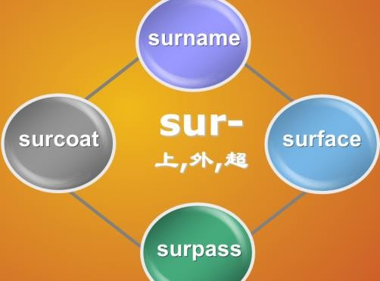surround: v.包围sir ruang de

* be surrounded by

The village is surrounded by many tall trees.

1. wood: n.树林forest 森林
2. beauty spot : 风景点

There are many beauty spots in Beijing.

1. hundred: n.百one hundred two hundred

hundreds of …成百上千的thousands of…成千上万的millions of…不计其数的

1. city: n.城市cities
2. through: prep.穿过 立体

across 平面

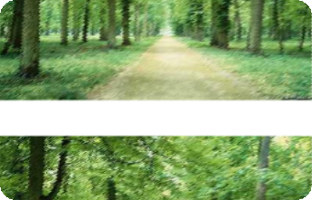

across the park across the street through the forest 7.visitor: n.参观者，游客，来访者

visit- visitor 8.tidy: adj.整齐的

untidy

1. litter: n.杂乱的东西 v. 乱扔
2. litter basket : 废物筐



Don’t litter ! No litter !

1. place: v.放 设计好的

12 put

Put it on the table.

I’ll place the table in the middle of the room.

1. throw: v. 扔 ， 抛 throw- threw- thrown throw away sth.

You can throw away the old books.

1. rubbish: n.垃圾trash n. (美式)
2. count: v.数，点

The baby can count from one to twenty. count sb. in: 把…算进去

Count me in. 算我一个。

Count Sam in. 把 Sam 算进去。

1. cover: v.覆盖

be covered with…

The trees are covered with heavy snow.

1. piece: n.碎片

put it into pieces 17.tyre: n.轮胎18.rusty: adj.生锈的

1. among: prep.在…之间between, 两者之间

Just between you and me.

在李宇春,芙蓉姐姐,和凤姐三个人之中你最喜欢谁？

Which one do you like best among…?

1. prosecute: v.依法处置被依法处置：

be prosecuted

# He is prosecuted.

**They were prosecuted.**

**Lesson 143 课文讲解**

1. a walk through the woods

林中漫步

a walk on the road

1. 我住在一个古老的镇上。

这个镇被一个美丽的小树林围绕。

I live in an old town.

The town is surrounded by beautiful woods.

我住在一个古老的镇上。 被一个美丽的小树林围绕的 I live in an old town

which\that is surrounded by beautiful woods.

1. On Sunday 在周日

On Sundays 每逢周日

1. Hundreds of people come from the city to see our town and to walk through the woods.
2. Visitors have been asked to keep the woods… have been done :已经被

keep sth. + adj. 保持… 保持教室安静整洁



keep the classroom clean and tidy

1. … have been placed under the trees… have been done: 已经被…
2. What I saw made me very sad.

I saw. 句子作主语- 主语从句。

引导词：what

翻译：我所看到的，使得我很伤心。我所听到的一切使我很愤怒。

What I heard made me very angry. 他所做的一切使我很开心。

What he did made me very happy. 他所学到的一切使他很智慧。

What he studied made him very intelligent.

1. …and the ground was covered with pieces of paper, cigarette ends,… be covered with… 被覆盖

cigarette ends 烟头

1. I found a sign which said…

我发现一个牌子，上面写着… 我收到一张明信片，上面写着… I got a postcard which said…

1. Anyone who leaves litter…will be prosecuted.

任何人 将会被依法处置。在树林扔垃圾的

任何在树林扔垃圾的人都将会会依法处置。

# Lesson 143 语法讲解

被动语态

# 他已经被邀请了两次了。已经被邀请 = has been invited He has been invited twice

1. **家务很快就被他做完了。很快做完= will be finished**

**The housework will be finished by him soon.**

1. **地面已经被大雪覆盖了。已经被覆盖= has been covered**

**The ground has been covered with heavy snow. 4.这座大楼马上就要建成了。**

**要建成= will be built**

**The building will be built soon.**

He hasn’t been served yet.

现在完成的被动

He will be served soon.

一般将来的被动

新概念一册学习总结：

1. 整本书的体系：

1- 30 、31-98、99-144

1. 重点是词法& 句法；
2. 单词慢慢记；
3. 多学几遍。
4. 31 现在进行
5. 47一般现在
6. 67 一般过去
7. 83 现在完成
8. 91 一般将来

# Lesson 144 单词句型讲解

**Lesson 143&144 知识拓展**